EXTERNAL RS232

CONTROL GUIDE

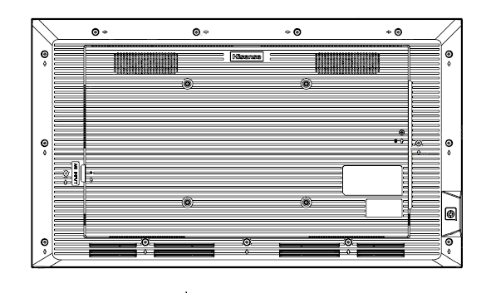

32/43/50/55/65/75/86DM66D

43/50/55/65/75/86GM50D

46/55VW25E

55WH80E/55WH80F

43/50/55/65/75/85DP30FE

Note: The terminals of different models may be different, please refer to the actual ones.

**Version & Revision History**

|  |  |  |
| --- | --- | --- |
| Version | Description | Date |
| V1.0 | The initial release | 2023-12 |
| V1.1 | 1. Fix the example command of “Set Screen Aspect Ratio”  2. Fix the example command of “Query Screen Status”  3. Add note of “Monitor ID”  4. Fix “Power On” Command. The range of Monitor ID can be set from 0x00 -0xFF. | 2024-8-15 |
| V1.2 | 1. Add command of “HDMI3 Input” | 2025-3-31 |
| V1.3 | 1. Add command “Set Max_Backlight” 2. Add command “Set Min_Backlight” 3. Add command “Set Brightness_Ambient Light” 4. Add command “Set All Ambient Light” 5. Add command “Query Max_Backlight” 6. Add command “Query Min_Backlight” 7. Add command “Query Brightness_Ambient Light” 8. Add command “Query All Ambient Light” | 2025-5-16 |
| V1.4 |  | 2025-6-9 |
|  |  |  |
|  |  |  |
|  |  |  |

# **INTRODUCTION**

Our users can control a Hisense display from an external source via RS-232. This user guide will provide all of the command structures and system parameters required to confidently control Hisense commercial displays via a PC or a 3rd party control system.

# **FORMATS**

HISENSE RS232 commands are HEX codes, not ASCII format.

Where applicable, codes contain the ID of the screen you are trying to control. A value of “00” will broadcast the command to all of the screens connected to the RS232 port, for this case, there is no feedback from devices. This might be all of the panels in a video wall daisy chained together for control. A value of “01” for example, will lead to control of the panel with ID 01 only. The default ID of the device is 01, each device in a video wall must set a unique ID. If the ID in command is different with the device ID, there is no feedback from device and this command cannot work. Depending on device configuration, some commands may not work, please check details below.

If you encounter problems when using RS-232 command, for example, the command cannot find or work, please try to upgrade device software to latest version.

RS232 commands require an XOR operation on some of its HEX bytes in order to generate the “checksum byte”. Example codes are given and XOR calculations can be made using this online calculator: <https://onlinehextools.com/xor-hex-numbers>

Each HEX number from the code that needs to be XORed is input into the left hand box on the page, each on a separate line. The XORed result is shown in the right hand box on the page.

You may install USB-to-Serial Bridge Driver, and RS232 serial terminal software on your PC, for example, Hercules SETUP utility or SSCOM.

# **DM66D SERIES - 24/7 DIGITAL SIGNAGE**

# **GM50D SERIES - 18/7 DIGITAL SIGNAGE**

## **Connectivity Diagram**



# **VW25E SERIES - 24/7 VIDEO WALL**

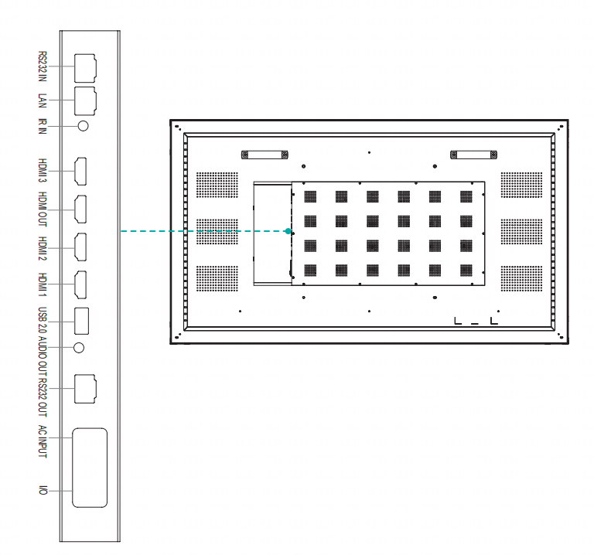

# **55WH80E/55WH80F SERIES - 24/7 WINDOW FACING**

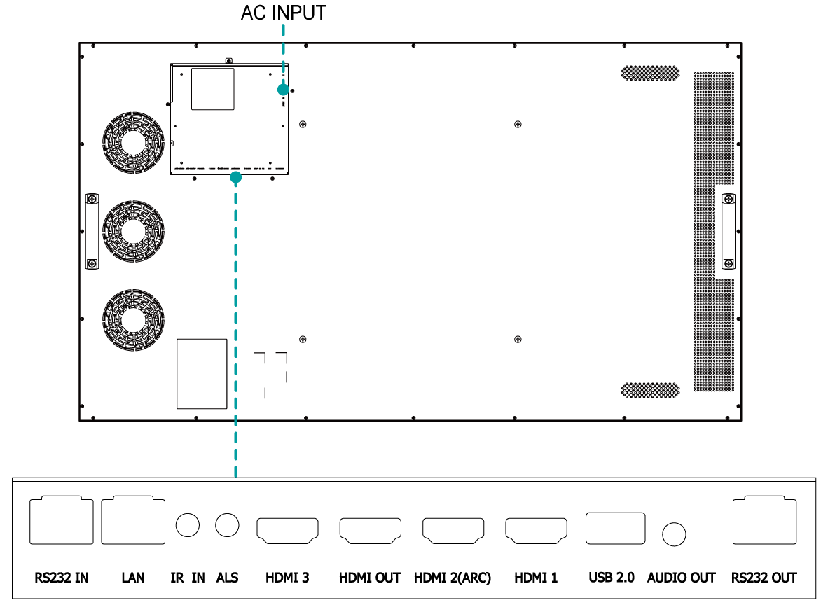

# DP30FE SERIES - 16/7 DIGITAL SIGNAGE

## 

## **RS232 Connectivity Illustration**

The following graphs illustrate the connectivity between a PC and the device.

There is already a RJ45-RS232 cable in box, if you’d like to use USB port on PC, you may want to prepare a USB-RS232 cable in advance, please note that the DB-9 connectors of the two cables should be male/female in pairs for this case.

## **Dispaly Pin Configuration**

|  |  |
| --- | --- |
| RS232 -IN RJ-45 Jack (Female) |  |
|  | |  |  | | --- | --- | | **Pin** | **Signal** | | **1** |  | | **2** |  | | **3** | GND | | **4** | IR | | **5** | RX(for Display) | | **6** | +5VDC | | **7** |  | | **8** | TX(for Display) | |

**Note: If IR input is not required, leave pin4&pin6 NC. Do not connect any other wire.**

The wiring method is as follows.

Method 1 : Connect the computer directly to the display



Method 2 :Using attachment lines

Included in the box – 1 x RJ45(Male) – DB-9F(Female)-RS 232 cable

Please use table below when wiring a cable:

|  |  |
| --- | --- |
| Pin out Connection | |
| RJ45(Male) | DB-9F(Female) |
| 1 |  |
| 2 |  |
| 3 | 5 |
| 4 |  |
| 5 | 3 |
| 6 |  |
| 7 |  |
| 8 | 2 |



## **Data Parameters**

|  |  |
| --- | --- |
| DM/GM-SERIES | |
| **Baud Rate** | 9600 |
| **Data length (bits)** | 8 |
| **Parity** | None |
| **Stop bit** | 1 |
| **Flow control** | None |

## **Command Format**

PC -> Digital Signage:

|  |  |  |  |  |  |  |  |  |  |  |  |  |  |  |
| --- | --- | --- | --- | --- | --- | --- | --- | --- | --- | --- | --- | --- | --- | --- |
| Header  (2 Bytes) | | Length  (2 Bytes) | | Command  (4 Bytes) | | | | Monitor ID (1 Byte) | Data  (N Bytes) | | | Checksum  (1 Bytes) | End  (2 Bytes) | |
| DD | FF |  |  |  |  |  |  |  |  |  |  |  | BB | CC |

DIGITAL SIGNAGE -> PC：

|  |  |  |  |  |  |  |  |  |  |  |  |  |  |  |
| --- | --- | --- | --- | --- | --- | --- | --- | --- | --- | --- | --- | --- | --- | --- |
| Header  (2 Bytes) | | Length  (2 Bytes) | | Command  (4 Bytes) | | | | Monitor ID (1 Byte) | Data  (N Bytes) | | | Checksum  (1 Bytes) | End  (2 Bytes) | |
| AB | AB |  |  |  |  |  |  |  |  |  |  |  | CD | CD |

Note:

1. Length is the number of bytes of Command, Data and Checksum
2. Checksum is XOR of Length, Command, Monitor ID and Data
3. Monitor ID. The range of Monitor ID is from 0x01 to 0xFF, supporting 255 devices to be connected to the network. 0x00 is the broadcast address, and all devices will execute the instructions sent with this ID, but will not return the instructions.

## **RS232 Command**

|  |  |  |  |
| --- | --- | --- | --- |
| **Description** | **Command (HEX Bytes)** | **Example (PC -> Digital Signage ID 01)** | **Digital Signage -> PC** |
| **Power On** | DD FF 00 08 C1 15 00 00 xx BB BB yy BB CC | DDFF0008C115000001BBBBDDBBCC | AB AB 00 08 C1 15 00 00 xx BB BB yy CD CD  When Digital Signage is in standby sate, send this command will get one feedback from Digital Signage, once Digital Signage starts up, it will send feedback again. |
| **Power Off** | DD FF 00 08 C1 15 00 00 xx AA AA yy BB CC | DD FF 00 08 C1 15 00 00 01 AA AA DD BB CC | AB AB 00 08 C1 15 00 00 xx AA AA yy CD CD |
| **Screen Off** | DD FF 00 07 C1 31 00 00 xx 00 yy BB CC | DD FF 00 07 C1 31 00 00 01 00 F6 BB CC | AB AB 00 07 C1 31 00 00 xx 00 yy CD CD |
| **Screen On** | DD FF 00 07 C1 31 00 00 xx 01 yy BB CC | DD FF 00 07 C1 31 00 00 01 01 F7 BB CC | AB AB 00 07 C1 31 00 00 xx 01 yy CD CD |
| **Reboot** | DD FF 00 06 C1 1E 00 00 xx yy BB CC | DD FF 00 06 C1 1E 00 00 01 D8 BB CC | AB AB 00 06 C1 1E 00 00 xx yy CD CD |
| **Set AC Power On Mode** | DD FF 00 07 C1 FF 00 09 xx zz yy BB CC | DDFF0007C1FF0009010031BBCC  zz: power on mode. 00 – direct, 01 – last, 02 – standby  direct: DD FF 00 07 C1 FF 00 09 01 00 31 BB CC  last: DD FF 00 07 C1 FF 00 09 01 01 30 BB CC  standby: DD FF 00 07 C1 FF 00 09 01 02 33 BB CC | AB AB 00 07 C1 FF 00 09 xx zz yy CD CD |
| **DP Input** | DD FF 00 07 C1 08 00 00 xx 16 yy BB CC | DDFF0007C10800000116D9BBCC | AB AB 00 07 C1 08 00 00 xx 16 yy CD CD |
| **VGA Input** | DD FF 00 07 C1 08 00 00 xx 17 yy BB CC | DDFF0007C10800000117D8BBCC | AB AB 00 07 C1 08 00 00 xx 17 yy CD CD |
| **HDMI1 Input** | DD FF 00 07 C1 08 00 00 xx 0E yy BB CC | DDFF0007C1080000010EC1BBCC | AB AB 00 07 C1 08 00 00 xx 0E yy CD CD |
| **HDMI2 Input** | DD FF 00 07 C1 08 00 00 xx 0F yy BB CC | DDFF0007C1080000010FC0BBCC | AB AB 00 07 C1 08 00 00 xx 0F yy CD CD |
| **HDMI3 Input** | DD FF 00 07 C1 08 00 00 xx 10 yy BB CC | DDFF0007C1080000010DFBBCC | AB AB 00 07 C1 08 00 00 xx 10 yy CD CD |
| **PC Input** | DD FF 00 07 C1 08 00 00 xx 0C yy BB CC | DDFF0007C1080000010CC3BBCC | AB AB 00 07 C1 08 00 00 xx 0C yy CD CD |
| **DVI Input** | DD FF 00 07 C1 08 00 00 xx 09 yy BB CC | DDFF0007C10800000109C6BBCC | AB AB 00 07 C1 08 00 00 xx 09 yy CD CD |
| **Set Screen Aspect Ratio** | DD FF 00 07 C1 35 00 00 xx zz yy BB CC  Once this command is set, reboot Digital Signage, it will show with expected ratio | Landscape: DD FF 00 07 C1 35 00 00 00 00 F3 BB CC Portrait: DD FF 00 07 C1 35 00 00 00 01 F2 BB CC | AB AB 00 07 C1 35 00 00 xx zz yy CD CD |
| **Set Mute** | DD FF 00 07 C1 26 00 00 xx 01 yy BB CC | DDFF0007C12600000101E0BBCC | AB AB 00 07 C1 26 00 00 xx 01 yy CD CD |
| **Set Unmute** | DD FF 00 07 C1 26 00 00 xx 00 yy BB CC | DDFF0007C12600000100E1BBCC | AB AB 00 07 C1 26 00 00 xx 00 yy CD CD |
| **Set Volume** | DD FF 00 07 C1 27 00 00 xx zz yy BB CC | DDFF0007C12700000101E1BBCC zz: volume range 0-100 | AB AB 00 07 C1 27 00 00 xx zz yy CD CD |
| **Set Backlight Brightness** | DD FF 00 08 C1 32 00 00 xx 06 zz yy BB CC | ex: set brightness to 32 - zz = 0x20 DDFF0008C1320000010620DCBBCC | AB AB 00 08 C1 32 00 00 xx 06 zz CD CD |
| **Set Backlight Brightness Auto Adjust** | DD FF 00 07 C1 34 00 00 xx zz yy BB CC | ex: set brightness auto adust off DDFF0007C13400000100F3BBCC zz = 00 - off, 01 - on | AB AB 00 07 C1 34 00 00 xx zz yy CD CD |
| **Set Date** | DD FF 00 09 C1 1C 00 00 xx zz zz zz yy BB CC | ex: set date to 23.Jan.2 DDFF0009C11C000001170102C1BBCC zz zz zz = Year Month Day | AB AB 00 09 C1 1C 00 00 xx zz zz zz yy CD CD zz zz zz = FF FF FF when error |
| **Set Time** | DD FF 00 09 C1 1D 00 00 xx zz zz zz yy BB CC | ex: set time to 12:25:2 DDFF0009C11D0000010C1902C3BBCC zz zz zz = Hour Minute Second | AB AB 00 09 C1 1D 00 00 xx zz zz zz yy CD CD zz zz zz = FF FF FF when error |
| **Set Schedule for Power On** | DD FF 00 09 C1 3E 00 00 xx tt zz zz yy BB CC | ex: power on at 9:10 every day DDFF0009C13E00000101090AF5BBCC tt = 00 - turn off schedule, 01 - everyday  zz zz = Hour Minute  Tips: If the device has been set to power on and off at a scheduled time, sending this command will clear the original settings, and leaving only the one sent. | AB AB 00 09 C1 3E 00 00 xx zz zz zz yy CD CD |
| **Set Schedule for Power Off** | DD FF 00 09 C1 3F 00 00 xx tt zz zz yy BB CC | ex: power off at 18:10 every day DDFF0009C13F00000101120AEFBBCC tt = 0 - turn off schedule, 1 - everyday  zz zz = Hour Minute  Tips: If the device has been set with a timed power on/off command, all previously set power on/off will be turned off | AB AB 00 09 C1 3F 00 00 xx zz zz zz yy CD CD |
| **Set Brightness** | DD FF 00 07 C1 36 00 00 xx zz yy BB CC  current source must be: DP, VGA, HDMI, PC, DVI | ex: set brightness to 32 - zz = 0x20 DDFF0007C13600000120D1BBCC | AB AB 00 07 C1 36 00 00 xx zz yy CD CD |
| **Set Contrast** | DD FF 00 07 C1 37 00 00 xx zz yy BB CC  current source must be: DP, VGA, HDMI, PC, DVI | ex: set contrast to 32 - zz = 0x20 DDFF0007C13700000120D0BBCC | AB AB 00 07 C1 37 00 00 xx zz yy CD CD |
| **Set Sharpness** | DD FF 00 07 C1 38 00 00 xx zz yy BB CC  current source must be: DP, VGA, HDMI, PC, DVI | ex: set sharpness to 32 - zz = 0x20 DDFF0007C13800000120DFBBCC | AB AB 00 07 C1 38 00 00 xx zz yy CD CD |
| **Set Color Temperature** | DD FF 00 07 C1 39 00 00 xx zz yy BB CC  current source must be: DP, VGA, HDMI, PC, DVI | ex: set colour temperature to 32 - zz = 0x20 DDFF0007C13900000120DEBBCC | AB AB 00 07 C1 39 00 00 xx zz yy CD CD |
| **Set Noise Reduction** | DD FF 00 07 C1 3A 00 00 xx zz yy BB CC  current source must be: DP, VGA, HDMI, PC, DVI | ex: set noise reduction to High - zz = 0x03 DDFF0007C13A00000103FEBBCC zz = 01 - low, 02 - medium, 03 - high, 04 - auto, 00 – off | AB AB 00 07 C1 3A 00 00 xx zz yy CD CD |
| **Set Image Scaling** | DD FF 00 07 C1 3B 00 00 xx zz yy BB CC  current source must be: DP, VGA, HDMI, PC, DVI | ex: set image scaling to Full - zz = 0x03 DDFF0007C13B00000103FFBBCC zz = 00 - full, 01 - 16:9, 02 - 4:3, 03 - scaling 1, 04 - scaling 2, 05 - point to point | AB AB 00 07 C1 3B 00 00 xx zz yy CD CD |
| **Set Picture Mode** | DD FF 00 07 C1 0F 06 00 xx zz yy BB CC | ex: set picture mode to movie mode - zz = 0x03 DDFF0007C10F060001030CBBCC zz = 00 - standard, 01 - bright, 02 - soft, 03 - Movie, 04 - Text, 5 - gaming 12 – natural | AB AB 00 07 C1 0F 06 00 xx zz yy CD CD |
| **Set Sound Mode** | DD FF 00 07 C1 FF 00 03 xx zz yy BB CC | ex: set sound mode to standard mode - zz = 0x00 DDFF0007C1FF000301003BBBCC  zz = 00 - standard，01 - music, 02 - news, 08 - movie, 10 - sports，20 - custom, 30 - voice, 40 - meeting | AB AB 00 07 C1 FF 00 03 xx zz yy CD CD |
| **Set Eye Protection Mode** | DD FF 00 07 C1 FF 00 1E xx zz yy BB CC | ex: set eye protection mode on - zz = 0x01 DDFF0007C1FF001E010127BBCC zz = 00 - off, 01 - on | AB AB 00 07 C1 FF 00 1E xx zz yy CD CD |
| **VGA Auto Adjust** | DD FF 00 07 C1 01 00 00 xx yy BB CC  current source must be VGA | ex: VGA Auto Adjust DDFF0007C101000001C6BBCC zz = 00 - off, 01 – on | AB AB 00 07 C1 01 00 00 xx yy CD CD |
| **Set anti-burn-in (image retention)** | DD FF 00 07 C1 33 00 00 xx zz yy BB CC | ex: set anti-burn-in on DDFF0007C13300000101F4BBCC zz = 00 - off, 01 - on | AB AB 00 07 C1 33 00 00 xx zz yy CD CD |
| **Set Power on delay** | DD FF 00 07 C1 3C 00 00 xx zz yy BB CC | ex: set power on delay to 10s DDFF0007C13C0000010AF1BBCC zz = 00 - off, others - delay time, range: 2s - 255s | AB AB 00 07 C1 3C 00 00 xx zz yy CD CD |
| **Set Video Wall** | DD FF 00 09 C1 0A 00 00 xx zz zz zz yy BB CC | ex: vertical 3 devices, horizontal 4 devices, device position: 6 DDFF0009C10A000001030406C2BBCC zz: how many devices in vertical zz: how many devices in horizontal zz: current device position |  |
| **Set Static IP Address of LAN** | DD FF 00 16 C1 1B 30 00 xx zz … zz yy BB CC | Ex: set IP 10.16.150.225, subnet mask: 255.255.248.0, gateway: 10.16.144.1, DNS: 10.16.144.2  DDFF0016C11B3000010A1096E1FFFFF8000A1090010A10900249BBCC  zz .. zz - 16 bytes, IP address - 4 bytes, Subnet mask - 4 bytes, gateway - 4 bytes, DNS - 4 bytes | AB AB 00 16 C1 1B 30 00 xx zz … zz yy CD CD |
| **Set USB Lock** | DD FF 00 07 C1 FF 00 0E xx zz yy BB CC | ex: lock USB DDFF0007C1FF000E010036BBCC zz = 00 - lock USB, 01 - enable USB | AB AB 00 07 C1 FF 00 0E xx zz yy CD CD |
| **Factory Reset** | DD FF 00 06 C1 10 00 00 xx yy BB CC | DDFF0006C110000001D6BBCC | AB AB 00 06 C1 10 00 00 xx yy CD CD |
| **Set Max_Backlight** | DD FF 00 07 C1 0F 00 05 xx zz yy BB CC | DD FF 00 07 C1 0F 00 05 01 50 9D BB CC  zz: the max backlight, range: 50-100 (0x32- 0x64) | AB AB 00 07 C1 0F 00 05 xx zz yy CD CD |
| **Set Min_Backlight** | DD FF 00 07 C1 0F 00 06 xx zz yy BB CC | DD FF 00 07 C1 0F 00 06 01 14 DA BB CC  zz: the min backlight, range: 0-49 (0x00- 0x31) | AB AB 00 07 C1 0F 00 06 xx zz yy CD CD |
| **Set Brightness_Ambient Light** | DD FF 00 09 C1 0F 00 07 xx zz1 zz2 zz3 yy BB CC | DD FF 00 09 C1 0F 00 07 01 02 03 20 E0 BB CC  The device with ID 01 and brightness 20 corresponds to an ambient light setting of 800 lux.  Note:  zz1: represents the corresponding brightness level. The corresponding relationship is as follows:   |  |  | | --- | --- | | zz1 | Brightness_ | | 0x00 | 0 | | 0x01 | 10 | | 0x02 | 20 | | 0x03 | 30 | | 0x04 | 40 | | 0x05 | 50 | | 0x06 | 60 | | 0x07 | 70 | | 0x08 | 80 | | 0x09 | 90 | | 0x0A | 100 |   zz2 zz3: Ambient light corresponding to each stage of brightness. Please set it within the corresponding range.  2000lux -> zz2 zz3: 0x 07 0xD0 | AB AB 00 09 C1 0F 00 07 xx zz1 zz2 zz3 yy CD CD |
| **Set All Ambient Light** | DD FF 00 1C C1 0F 00 08 xx zz1 zz2 … zz22 yy BB CC | |  |  |  | | --- | --- | --- | | **Data** | **Brightness_** | **Ambient Light** | | zz1 zz2 | 0 | 0-487  (0x00 0x00 - 0x01 0xE7) | | Zz3 zz4 | 10 | 500-987  (0x01 0xF4- 0x03 0xDB) | | Zz5 zz6 | 20 | 1000-1487  (0x03 0xE8 – 0x05 0xCF) | | Zz7 zz8 | 30 | 1500-1987  (0x05 0xDC – 0x07 0xC3) | | Zz9 zz10 | 40 | 2000-3987  (0x07 0xD0 – 0x0F 0x93) | | zz11 zz12 | 50 | 4000-9987  (0x01 0x90 – 0x27 0x03) | | zz13 zz14 | 60 | 10000-16987  (0x27 0x10 – 0x42 0x5B) | | zz15 zz16 | 70 | 17000-21987  (0x42 0x68 – 0x55 0xE3) | | zz17 zz18 | 80 | 22000-25987  (0x55 0xF0 – 0x65 0x83) | | zz19 zz20 | 90 | 26000-29987  (0x65 0x90 – 0x75 0x23) | | Zz21 zz22 | 100 | 30000-88000  (0x75 0x30 – 0x01 0x57 0xC0) | | AB AB 00 1C C1 0F 00 08 xx zz1 zz2 … zz22 yy CD CD |
| **Query Digital Signage Status** | DD FF 00 06 C1 28 00 00 xx yy BB CC | DDFF0006C128000001EEBBCC | AB AB 00 0C C1 28 00 00 xx zz zz zz zz zz zz yy CD CD zz: volume zz zz: 05 01 - PC, 05 02 - DVI, 05 03 - DP, 05 04 - HDMI2, 05 05 - HDMI1, 08 01 – VGA, 05 0B - HDMI3，05 00 - Android zz: 00 - power on, FF - power off zz: 01 - mute; 00 - unmute zz: 00 - no signal, 01 - has signal |
| **Query Screen Status** | DD FF 00 06 C1 32 00 01 xx yy BB CC | DD FF 00 06 C1 32 00 01 01 F5 BB CC | AB AB 00 07 C1 32 00 01 xx zz yy CD CD zz: 00 - screen off; 01 - screen on  eg:AB AB 00 07 C1 32 00 01 01 01 F5 CD CD |
| **Query Source** | DD FF 00 06 C1 1A 00 00 xx yy BB CC | DDFF0006C11A000001DCBBCC | AB AB 00 08 C1 1A 00 00 xx zz zz yy CD CD zz zz - source, refer to user menu for source definition |
| **Query SW Version** | DD FF 00 06 C1 1B 00 00 xx yy BB CC | DDFF0006C11B000001DDBBCC | AB AB 00 09 C1 1B 00 00 xx zz zz zz yy CD CD zz zz zz - Year Month Date |
| **Query Backlight Brightness** | DD FF 00 06 C1 3E 00 24 xx yy BB CC | DDFF0006C13E000001F8BBCC | AB AB 00 LL C1 3E 00 24 xx zz zz yy CD CD zz:01 - bright，02 - soft, 03 - auto adjust, 04 - stereo frequency conversion，05 - Comfort frequency conversion，06 - custom zz: when first zz is 06 custom, this byte means backlight brightness value: 0-30 LL: when first zz is zz, LL = 08, otherwise, LL = 07 |
| **Query Brightness** | DD FF 00 06 C1 36 00 01 xx yy BB CC | DDFF0006C136000101F0BBCC | AB AB 00 07 C1 36 00 01 xx zz yy CD CD zz is the brightness value |
| **Query Network Status** | DD FF 00 06 C1 FF 00 16 xx yy BB CC | DDFF0006C1FF0016012FBBCC | AB AB 00 07 C1 FF 00 16 xx zz yy CD CD zz: 00 - no network connection; 01 - network connected |
| **Query Sound Mode** | DD FF 00 06 C1 FF 00 02 xx yy BB CC | DDFF0006C1FF0002013BBBCC | AB AB 00 07 C1 FF 00 02 xx zz yy CD CD zz = 00 - standard，01 - music, 02 - news, 08 - movie, 10 - sports，20 - custom, 30 - voice, 40 - meeting |
| **Query AC Power On Status** | DD FF 00 06 C1 FF 00 08 xx yy BB CC | DDFF0006C1FF00080131BBCC | AB AB 00 07 C1 FF 00 08 xx zz yy CD CD zz: 00 - power on; 01 - Last mode; 02 - standby |
| **Query IP Address** | DD FF 00 06 C1 1B 20 00 xx yy BB CC | DDFF0006C11B200001FDBBCC | AB AB 00 16 C1 1B 20 00 xx zz … zz yy CD CD zz zz zz zz - IP address zz zz zz zz - Subnet mask zz zz zz zz Gateway zz zz zz zz – DNS  Note: The return value length of the DP30FE series should be changed from 0016 to 00XX |
| **Query Device Temperature** | DD FF 00 06 C1 FE 00 00 xx yy BB CC | DDFF0006C1FE00000138BBCC | AB AB 00 07 C1 FE 00 00 xx zz yy CD CD zz: temperature in centigrade |
| **Query Picture Mode** | DD FF 00 06 C1 6D 00 00 xx yy BB CC | DD FF 00 06 C1 6D 00 00 64 CE BB CC | AB AB 00 07 C1 6D 00 00 xx zz yy CD CD  zz: 00 – standard, 01 – bright, 06 – AI, 07 – user, 02 – soft, 03 – movie, 04 – text, 05 – game, 12- nature |
| **Query USB Status** | DD FF 00 06 C1 6E 00 00 xx yy BB CC | DD FF 00 06 C1 6E 00 00 64 CD BB CC | AB AB 00 07 C1 6E 00 00 xx zz yy CD CD  zz: 00 - off, 01 - on |
| **Query Eye Protection Mode** | DD FF 00 06 C1 FF 00 1D xx yy BB CC | DDFF0006C1FF001D0124BBCC | AB AB 00 07 C1 FF 00 1D xx zz yy CD CD zz: 00 - Off; 01 - On |
| **Query SN** | DD FF 00 06 C1 FF 00 0B xx yy BB CC | DDFF0006C1FF000B0132BBCC | AB AB 00 1D C1 FF 00 0B xx zz…zz yy CD CD zz .. zz: 23 bytes serial number |
| **Query Devicd ID** | DD FF 00 06 C1 FF 00 0D xx yy BB CC | DDFF0006C1FF000D0134BBCC | AB AB 00 26 C1 FF 00 0D xx zz…zz yy CD CD zz .. zz: 32 bytes device ID |
| **Query MAC Address** | DD FF 00 06 C1 6C 00 00 xx yy BB CC | DDFF0006C16C000001AABBCC | AB AB 00 0C C1 6C 00 00 xx zz…zz yy CD CD zz .. zz: 6 bytes |
| **Query volume** | DD FF 00 06 C1 7D 00 00 xx yy BB CC | DD FF 00 06 C1 7D 00 00 64 DE BB CC | AB AB 00 07 C1 7D 00 00 xx zz yy CD CD  zz: volume |
| **Query Serial Port ID** | DD FF 00 06 C1 1B 10 00 xx yy BB CC | DD FF 00 06 C1 1B 10 00 64 A8 BB CC | AB AB 00 06 C1 1B 10 00 xx zz yy CD CD  zz: serial port ID. Settings -> signal manager -> serial port ID |
| **Query brand** | DD FF 00 06 C1 FE 00 01 xx yy BB CC | DD FF 00 06 C1 FE 00 01 64 5C BB CC | AB AB 00 06 C1 FE 00 01 xx zz…zz yy CD CD  zz…zz: brand. ex: hisense (ASCII)  Note: The return value length of the DP30FE series should be changed from 0006 to 00XX |
| **Query model** | DD FF 00 06 C1 FE 00 02 xx yy BB CC | DD FF 00 06 C1 FE 00 02 64 5F BB CC | AB AB 00 06 C1 FE 00 02 xx zz…zz yy CD CD  zz…zz: model name  Note: The return value length of the DP30FE series should be changed from 0006 to 00XX |
| **Send Remote Controller Key Code** | DD FF 00 08 C1 17 00 00 xx zz zz yy BB CC | ex: send menu key: zz zz = 00 00 DDFF0008C1170000010000DFBBCC zz zz = 00 00 - Menu; 00 01 - UP, 00 02 - DOWN, 00 03 - LEFT, 00 04 - RIGHT， 00 05 - OK， 00 06 - Return, 00 07 - Source | AB AB 00 08 C1 17 00 00 xx zz zz yy CD CD |
| **Open Settings** | DD FF 00 06 C1 41 00 00 xx yy BB CC | DDFF0006C14100000187BBCC | AB AB 00 06 C1 41 00 00 xx yy CD CD |
| **Open Home** | DD FF 00 06 C1 FF 00 1A xx yy BB CC | DDFF0006C1FF001A0123BBCC | AB AB 00 06 C1 FF 00 1A xx yy CD CD |
| **Open CMS** | DD FF 00 06 C1 FF 00 13 xx yy BB CC | DDFF0006C1FF0013012ABBCC | AB AB 00 06 C1 FF 00 13 xx yy CD CD |
| **Open ScreenShare** | DD FF 00 06 C1 43 00 00 xx yy BB CC | DDFF0006C14300000185BBCC | AB AB 00 06 C1 43 00 00 xx yy CD CD |
| **Turn on Hotspot** | DD FF 00 06 C1 44 00 00 xx yy BB CC | DDFF0006C14400000182BBCC | AB AB 00 06 C1 44 00 00 xx yy CD CD |
| **Take Screenshot** | DD FF 00 06 C1 4B 00 00 xx yy BB CC | DDFF0006C14B0000018DBBCC | AB AB 00 06 C1 4B 00 00 xx yy CD CD |
| **Freeze Screen** | DD FF 00 07 C1 0F 08 00 xx zz yy BB CC | DD FF 00 07 C1 0F 08 00 01 01 C1 BB CC zz = 01 - freeze; 00 – unfreeze | AB AB 00 07 C1 0F 08 00 xx zz yy CD CD |
| **Query**  **Max_Backlight** | DD FF 00 06 C1 FE 00 04 xx yy BB CC | DD FF 00 06 C1 FE 00 04 01 50 6C BB CC  Set the maximum brightness to 80. | AB AB 00 07 C1 FE 00 04 xx zz yy CD CD |
| **Query**  **Min_Backlight** | DD FF 00 06 C1 FE 00 05 xx yy BB CC | DD FF 00 06 C1 FE 00 05 01 14 29 BB CC  Set the minimum brightness to 20 | AB AB 00 07 C1 FE 00 05 xx zz yy CD CD |
| **Query**  **Brightness_Ambient**  **Light** | DD FF 00 07 C1 FE 00 06 xx zz yy BB CC | |  |  | | --- | --- | | zz | Brightness_ | | 0x00 | 0 | | 0x01 | 10 | | 0x02 | 20 | | 0x03 | 30 | | 0x04 | 40 | | 0x05 | 50 | | 0x06 | 60 | | 0x07 | 70 | | 0x08 | 80 | | 0x09 | 90 | | 0x0A | 100 | | AB AB 00 09 C1 FE 00 06 xx zz1 zz2 zz3 yy CD CD |
| **Query All**  **Ambient**  **Light** | DD FF 00 06 C1 FE 00 07 xx yy BB CC | DD FF 00 06 C1 FE 00 07 01 3F BB CC | AB AB 00 1C C1 FE 00 07 xx zz1 zz2 … zz22 yy CD CD |



[www.hisense-b2b.com](http://www.hisense-b2b.com/)