

|  |  |  |
| --- | --- | --- |
| Platform Name | Product Name | System Version |
| MTK9666 | 32/43/50/55/65/75/86DM66D  43/50/55/65/75/86GM50D | Android 11.0 |

### V1.1



IP CONTROL UER MANUAL

**Feb, 2024 Hisense Commercial Display R&D**

**Version & Revision History**

|  |  |  |
| --- | --- | --- |
| Version | Description | Date |
| V1.0 | The initial release | 2023-12 |
| V1.1 | 1. Add wired wake-up operation steps 2. Delete the Power on command 3. Update the Screen Rotation command | 2024-2-28 |
| V1.2 | 1.Edit the example command for “Query screen status” | 2024-8-15 |
|  |  |  |
|  |  |  |
|  |  |  |
|  |  |  |
|  |  |  |

IP Control function support device local area network(LAN) deployment. The server and client are in the same LAN. The IP control software is a server. It supports TCP/IP network protocol and hex string command format. The software need to input the port number and start. After the starting the software, the client software connect the IP Control software server. The client need to input server IP and server port number.

Operation step is as below:

1. Open the IP control app

Start the “IP Control” from Apps on the monitor. Open the APK and show as below.

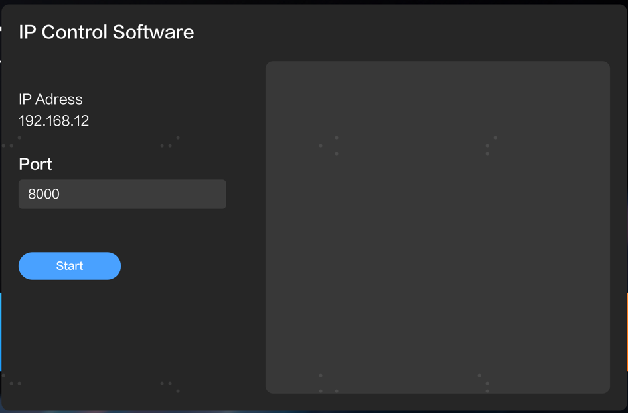

1. IP Address Set

IP Address(192.168.1.2) can not edit on the App. It needs to edit via the setting menu on the monitor

1. Set Port Number

The default port number is 8000. If the port 8000 is occupied, please change the port(5000-12000)

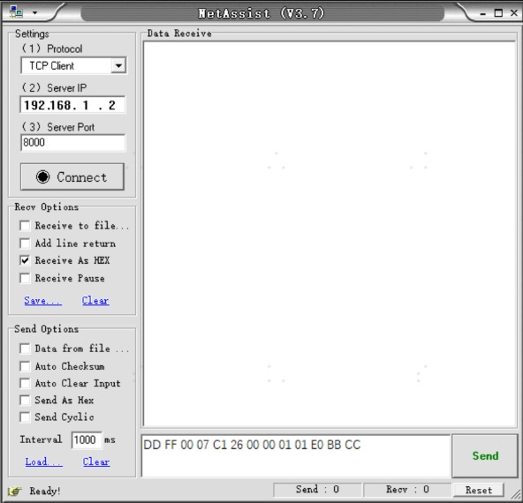

1. Start the IP Control(Server)

Click “Start” Button, it will show “Stop”; Click “Stop” Button, it will show “Start”.

1. Client App Connect to IP Control(Server)

You can use the Net Assist software. Select “TCP Client” from the Protocol on the setting, and set the server IP and server port. Finally, click the connect button. Please refer to picture as below.

1. Send Command

Connect successful, you can input the hex string command and click “Send” button.

**for example**: Mute Control Command-Mute ON DD FF 00 07 C1 26 00 00 01 01 E0 BB CC

**Note that**: IP Control Command is the same with the RS232 Command. Command format refer to User Manual.

1. Wake on Lan command

Wake On Command(Only Support Wired Network) need Wake on Lan software or send command according to the magic packet format.

Wake On Lan software wake up steps are as follows:

1. Switch on “Wake–on LAN”, Setting ->Switch on/off -> Wake-on LAN.
2. Make sure the monitor and PC are in the same Lan, and the monitor connect with wire.
3. Remember the wired MAC, IP address, Subnet Mask and the port number(IP control port).
4. Make sure IP Control working well.
5. Open Wake on Lan software, input the mac, IP, subnet mask and port, then click “Wake Up”, the monitor will be waked up.

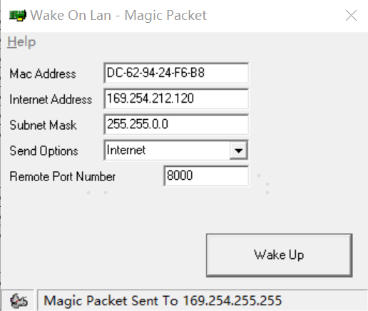

## IP Control Command

|  |  |  |  |
| --- | --- | --- | --- |
| **Description** | **Command (HEX Bytes)** | **Example (PC -> TV ID 01)** | **TV -> PC** |
| **Power Off** | DD FF 00 08 C1 15 00 00 xx AA AA yy BB CC | DD FF 00 08 C1 15 00 00 01 AA AA DD BB CC | AB AB 00 08 C1 15 00 00 xx AA AA yy CD CD |
| **Screen Off** | DD FF 00 07 C1 31 00 00 xx 00 yy BB CC | DD FF 00 07 C1 31 00 00 01 00 F6 BB CC | AB AB 00 07 C1 31 00 00 xx 00 yy CD CD |
| **Screen On** | DD FF 00 07 C1 31 00 00 xx 01 yy BB CC | DD FF 00 07 C1 31 00 00 01 01 F7 BB CC | AB AB 00 07 C1 31 00 00 xx 01 yy CD CD |
| **Reboot** | DD FF 00 06 C1 1E 00 00 xx yy BB CC | DD FF 00 06 C1 1E 00 00 01 D8 BB CC | AB AB 00 06 C1 1E 00 00 xx yy CD CD |
| **Set AC Power On Mode** | DD FF 00 07 C1 FF 00 09 xx zz yy BB CC | DDFF0007C1FF0009010031BBCC  zz: power on mode. 00 – direct, 01 – last, 02 – standby  direct: DD FF 00 07 C1 FF 00 09 01 00 31 BB CC  last: DD FF 00 07 C1 FF 00 09 01 01 30 BB CC  standby: DD FF 00 07 C1 FF 00 09 01 02 33 BB CC | AB AB 00 07 C1 FF 00 09 xx zz yy CD CD |
| **DP Input** | DD FF 00 07 C1 08 00 00 xx 16 yy BB CC | DDFF0007C10800000116D9BBCC | AB AB 00 07 C1 08 00 00 xx 16 yy CD CD |
| **VGA Input** | DD FF 00 07 C1 08 00 00 xx 17 yy BB CC | DDFF0007C10800000117D8BBCC | AB AB 00 07 C1 08 00 00 xx 17 yy CD CD |
| **HDMI1 Input** | DD FF 00 07 C1 08 00 00 xx 0E yy BB CC | DDFF0007C1080000010EC1BBCC | AB AB 00 07 C1 08 00 00 xx 0E yy CD CD |
| **HDMI2 Input** | DD FF 00 07 C1 08 00 00 xx 0F yy BB CC | DDFF0007C1080000010FC0BBCC | AB AB 00 07 C1 08 00 00 xx 0F yy CD CD |
| **PC Input** | DD FF 00 07 C1 08 00 00 xx 0C yy BB CC | DDFF0007C1080000010CC3BBCC | AB AB 00 07 C1 08 00 00 xx 0C yy CD CD |
| **DVI Input** | DD FF 00 07 C1 08 00 00 xx 09 yy BB CC | DDFF0007C10800000109C6BBCC | AB AB 00 07 C1 08 00 00 xx 09 yy CD CD |
| **Set Screen Rotation** | DD FF 00 07 C1 35 00 00 xx zz yy BB CC | set screep rotation: Landscape: DD FF 00 07 C1 35 00 00 00 00 F3 BB CC Portrait: DD FF 00 07 C1 35 00 00 00 01 F2 BB CC | AB AB 00 07 C1 35 00 00 xx zz yy CD CD |
| **Set Mute** | DD FF 00 07 C1 26 00 00 xx 01 yy BB CC | DDFF0007C12600000101E0BBCC | AB AB 00 07 C1 26 00 00 xx 01 yy CD CD |
| **Set Unmute** | DD FF 00 07 C1 26 00 00 xx 00 yy BB CC | DDFF0007C12600000100E1BBCC | AB AB 00 07 C1 26 00 00 xx 00 yy CD CD |
| **Set Volume** | DD FF 00 07 C1 27 00 00 xx zz yy BB CC | DDFF0007C12700000101E1BBCC zz: volume range 0-100 | AB AB 00 07 C1 27 00 00 xx zz yy CD CD |
| **Set Backlight Brightness** | DD FF 00 08 C1 32 00 00 xx 06 zz yy BB CC | ex: set brightness to 32 - zz = 0x20 DDFF0008C1320000010620DCBBCC | AB AB 00 08 C1 32 00 00 xx 06 zz CD CD |
| **Set Backlight Brightness Auto Adjust** | DD FF 00 07 C1 34 00 00 xx zz yy BB CC | ex: set brightness auto adust off DDFF0007C13400000100F3BBCC zz = 00 - off, 01 - on | AB AB 00 07 C1 34 00 00 xx zz yy CD CD |
| **Set Date** | DD FF 00 09 C1 1C 00 00 xx zz zz zz yy BB CC | ex: set date to 23.Jan.2 DDFF0009C11C000001170102C1BBCC zz zz zz = Year Month Day | AB AB 00 09 C1 1C 00 00 xx zz zz zz yy CD CD zz zz zz = FF FF FF when error |
| **Set Time** | DD FF 00 09 C1 1D 00 00 xx zz zz zz yy BB CC | ex: set time to 12:25:2 DDFF0009C11D0000010C1902C3BBCC zz zz zz = Hour Minute Second | AB AB 00 09 C1 1D 00 00 xx zz zz zz yy CD CD zz zz zz = FF FF FF when error |
| **Set Schedule for Power On** | DD FF 00 09 C1 3E 00 00 xx tt zz zz yy BB CC | ex: power on at 9:10 every day DDFF0009C13E00000101090AF5BBCC tt = 00 - turn off schedule, 01 - everyday  zz zz = Hour Minute  Tips: If the device has been set to power on and off at a scheduled time, sending this command will clear the original settings, and leaving only the one sent. | AB AB 00 09 C1 3E 00 00 xx zz zz zz yy CD CD |
| **Set Schedule for Power Off** | DD FF 00 09 C1 3F 00 00 xx tt zz zz yy BB CC | ex: power off at 18:10 every day DDFF0009C13F00000101120AEFBBCC tt = 0 - turn off schedule, 1 - everyday  zz zz = Hour Minute  Tips: If the device has been set with a timed power on/off command, all previously set power on/off will be turned off | AB AB 00 09 C1 3F 00 00 xx zz zz zz yy CD CD |
| **Set Brightness** | DD FF 00 07 C1 36 00 00 xx zz yy BB CC  current source must be: DP, VGA, HDMI, PC, DVI | ex: set brightness to 32 - zz = 0x20 DDFF0007C13600000120D1BBCC | AB AB 00 07 C1 36 00 00 xx zz yy CD CD |
| **Set Contrast** | DD FF 00 07 C1 37 00 00 xx zz yy BB CC  current source must be: DP, VGA, HDMI, PC, DVI | ex: set contrast to 32 - zz = 0x20 DDFF0007C13700000120D0BBCC | AB AB 00 07 C1 37 00 00 xx zz yy CD CD |
| **Set Sharpness** | DD FF 00 07 C1 38 00 00 xx zz yy BB CC  current source must be: DP, VGA, HDMI, PC, DVI | ex: set sharpness to 32 - zz = 0x20 DDFF0007C13800000120DFBBCC | AB AB 00 07 C1 38 00 00 xx zz yy CD CD |
| **Set Color Temperature** | DD FF 00 07 C1 39 00 00 xx zz yy BB CC  current source must be: DP, VGA, HDMI, PC, DVI | ex: set colour temperature to 32 - zz = 0x20 DDFF0007C13900000120DEBBCC | AB AB 00 07 C1 39 00 00 xx zz yy CD CD |
| **Set Noise Reduction** | DD FF 00 07 C1 3A 00 00 xx zz yy BB CC  current source must be: DP, VGA, HDMI, PC, DVI | ex: set noise reduction to High - zz = 0x03 DDFF0007C13A00000103FEBBCC zz = 01 - low, 02 - medium, 03 - high, 04 - auto, 00 – off | AB AB 00 07 C1 3A 00 00 xx zz yy CD CD |
| **Set Image Scaling** | DD FF 00 07 C1 3B 00 00 xx zz yy BB CC  current source must be: DP, VGA, HDMI, PC, DVI | ex: set image scaling to Full - zz = 0x03 DDFF0007C13B00000103FFBBCC zz = 00 - full, 01 - 16:9, 02 - 4:3, 03 - scaling 1, 04 - scaling 2, 05 - point to point | AB AB 00 07 C1 3B 00 00 xx zz yy CD CD |
| **Set Picture Mode** | DD FF 00 07 C1 0F 06 00 xx zz yy BB CC | ex: set picture mode to movie mode - zz = 0x03 DDFF0007C10F060001030CBBCC zz = 00 - standard, 01 - bright, 02 - soft, 03 - Movie, 04 - Text, 5 - gaming 12 – natural | AB AB 00 07 C1 0F 06 00 xx zz yy CD CD |
| **Set Sound Mode** | DD FF 00 07 C1 FF 00 03 xx zz yy BB CC | ex: set sound mode to standard mode - zz = 0x00 DDFF0007C1FF000301003BBBCC  zz = 00 - standard，01 - music, 02 - news, 08 - movie, 10 - sports，20 - custom, 30 - voice, 40 - meeting | AB AB 00 07 C1 FF 00 03 xx zz yy CD CD |
| **Set Eye Protection Mode** | DD FF 00 07 C1 FF 00 1E xx zz yy BB CC | ex: set eye protection mode on - zz = 0x01 DDFF0007C1FF001E010127BBCC zz = 00 - off, 01 - on | AB AB 00 07 C1 FF 00 1E xx zz yy CD CD |
| **VGA Auto Adjust** | DD FF 00 07 C1 01 00 00 xx yy BB CC  current source must be VGA | ex: VGA Auto Adjust DDFF0007C101000001C6BBCC zz = 00 - off, 01 – on | AB AB 00 07 C1 01 00 00 xx yy CD CD |
| **Set anti-burn-in (image retention)** | DD FF 00 07 C1 33 00 00 xx zz yy BB CC | ex: set anti-burn-in on DDFF0007C13300000101F4BBCC zz = 00 - off, 01 - on | AB AB 00 07 C1 33 00 00 xx zz yy CD CD |
| **Set Power on delay** | DD FF 00 07 C1 3C 00 00 xx zz yy BB CC | ex: set power on delay to 10s DDFF0007C13C0000010AF1BBCC zz = 00 - off, others - delay time, range: 2s - 255s | AB AB 00 07 C1 3C 00 00 xx zz yy CD CD |
| **Set Video Wall** | DD FF 00 09 C1 0A 00 00 xx zz zz zz yy BB CC | ex: vertical 3 devices, horizontal 4 devices, device position: 6 DDFF0009C10A000001030406C2BBCC zz: how many devices in vertical zz: how many devices in horizontal zz: current device position |  |
| **Set Static IP Address of LAN** | DD FF 00 16 C1 1B 30 00 xx zz … zz yy BB CC | Ex: set IP 10.16.150.225, subnet mask: 255.255.248.0, gateway: 10.16.144.1, DNS: 10.16.144.2  DDFF0016C11B3000010A1096E1FFFFF8000A1090010A10900249BBCC  zz .. zz - 16 bytes, IP address - 4 bytes, Subnet mask - 4 bytes, gateway - 4 bytes, DNS - 4 bytes | AB AB 00 16 C1 1B 30 00 xx zz … zz yy CD CD |
| **Set USB Lock** | DD FF 00 07 C1 FF 00 0E xx zz yy BB CC | ex: lock USB DDFF0007C1FF000E010036BBCC zz = 00 - lock USB, 01 - enable USB | AB AB 00 07 C1 FF 00 0E xx zz yy CD CD |
| **Factory Reset** | DD FF 00 06 C1 10 00 00 xx yy BB CC | DDFF0006C110000001D6BBCC | AB AB 00 06 C1 10 00 00 xx yy CD CD |
| **Query TV Status** | DD FF 00 06 C1 28 00 00 xx yy BB CC | DDFF0006C128000001EEBBCC | AB AB 00 0C C1 28 00 00 xx zz zz zz zz zz zz yy CD CD zz: volume zz zz: 05 01 - PC, 05 02 - DVI, 05 03 - DP, 05 04 - HDMI2, 05 05 - HDMI1, 08 01 – VGA, 05 0B - HDMI3，05 00 - Android zz: 00 - power on, FF - power off zz: 01 - mute; 00 - unmute zz: 00 - no signal, 01 - has signal |
| **Query Screen Status** | DD FF 00 06 C1 32 00 01 xx yy BB CC | DD FF 00 06 C1 32 00 01 01 F5 BB CC | AB AB 00 07 C1 32 00 01 xx zz yy CD CD zz: 00 - screen off; 01 - screen on  eg:AB AB 00 07 C1 32 00 01 01 01 F5 CD CD |
| **Query Source** | DD FF 00 06 C1 1A 00 00 xx yy BB CC | DDFF0006C11A000001DCBBCC | AB AB 00 08 C1 1A 00 00 xx zz zz yy CD CD zz zz - source, refer to user menu for source definition |
| **Query SW Version** | DD FF 00 06 C1 1B 00 00 xx yy BB CC | DDFF0006C11B000001DDBBCC | AB AB 00 09 C1 1B 00 00 xx zz zz zz yy CD CD zz zz zz - Year Month Date |
| **Query Backlight Brightness** | DD FF 00 06 C1 3E 00 24 xx yy BB CC | DDFF0006C13E000001F8BBCC | AB AB 00 LL C1 3E 00 24 xx zz zz yy CD CD zz:01 - bright，02 - soft, 03 - auto adjust, 04 - stereo frequency conversion，05 - Comfort frequency conversion，06 - custom zz: when first zz is 06 custom, this byte means backlight brightness value: 0-30 LL: when first zz is zz, LL = 08, otherwise, LL = 07 |
| **Query Brightness** | DD FF 00 06 C1 36 00 01 xx yy BB CC | DDFF0006C136000101F0BBCC | AB AB 00 07 C1 36 00 01 xx zz yy CD CD zz is the brightness value |
| **Query Network Status** | DD FF 00 06 C1 FF 00 16 xx yy BB CC | DDFF0006C1FF0016012FBBCC | AB AB 00 07 C1 FF 00 16 xx zz yy CD CD zz: 00 - no network connection; 01 - network connected |
| **Query Sound Mode** | DD FF 00 06 C1 FF 00 02 xx yy BB CC | DDFF0006C1FF0002013BBBCC | AB AB 00 07 C1 FF 00 02 xx zz yy CD CD zz = 00 - standard，01 - music, 02 - news, 08 - movie, 10 - sports，20 - custom, 30 - voice, 40 - meeting |
| **Query AC Power On Status** | DD FF 00 06 C1 FF 00 08 xx yy BB CC | DDFF0006C1FF00080131BBCC | AB AB 00 07 C1 FF 00 08 xx zz yy CD CD zz: 00 - power on; 01 - Last mode; 02 - standby |
| **Query IP Address** | DD FF 00 06 C1 1B 20 00 xx yy BB CC | DDFF0006C11B200001FDBBCC | AB AB 00 16 C1 1B 20 00 xx zz … zz yy CD CD zz zz zz zz - IP address zz zz zz zz - Subnet mask zz zz zz zz Gateway zz zz zz zz – DNS  Note: The return value length of the DP30FE series should be changed from 0016 to 00XX |
| **Query Device Temperature** | DD FF 00 06 C1 FE 00 00 xx yy BB CC | DDFF0006C1FE00000138BBCC | AB AB 00 07 C1 FE 00 00 xx zz yy CD CD zz: temperature in centigrade |
| **Query Picture Mode** | DD FF 00 06 C1 6D 00 00 xx yy BB CC | DD FF 00 06 C1 6D 00 00 64 CE BB CC | AB AB 00 07 C1 6D 00 00 xx zz yy CD CD  zz: 00 – standard, 01 – bright, 06 – AI, 07 – user, 02 – soft, 03 – movie, 04 – text, 05 – game, 12- nature |
| **Query USB Status** | DD FF 00 06 C1 6E 00 00 xx yy BB CC | DD FF 00 06 C1 6E 00 00 64 CD BB CC | AB AB 00 07 C1 6E 00 00 xx zz yy CD CD  zz: 00 - off, 01 - on |
| **Query Eye Protection Mode** | DD FF 00 06 C1 FF 00 1D xx yy BB CC | DDFF0006C1FF001D0124BBCC | AB AB 00 07 C1 FF 00 1D xx zz yy CD CD zz: 00 - Off; 01 - On |
| **Query SN** | DD FF 00 06 C1 FF 00 0B xx yy BB CC | DDFF0006C1FF000B0132BBCC | AB AB 00 1D C1 FF 00 0B xx zz…zz yy CD CD zz .. zz: 23 bytes serial number |
| **Query Devicd ID** | DD FF 00 06 C1 FF 00 0D xx yy BB CC | DDFF0006C1FF000D0134BBCC | AB AB 00 26 C1 FF 00 0D xx zz…zz yy CD CD zz .. zz: 32 bytes device ID |
| **Query MAC Address** | DD FF 00 06 C1 6C 00 00 xx yy BB CC | DDFF0006C16C000001AABBCC | AB AB 00 0C C1 6C 00 00 xx zz…zz yy CD CD zz .. zz: 6 bytes |
| **Query volume** | DD FF 00 06 C1 7D 00 00 xx yy BB CC | DD FF 00 06 C1 7D 00 00 64 DE BB CC | AB AB 00 07 C1 7D 00 00 xx zz yy CD CD  zz: volume |
| **Query Serial Port ID** | DD FF 00 06 C1 1B 10 00 xx yy BB CC | DD FF 00 06 C1 1B 10 00 64 A8 BB CC | AB AB 00 06 C1 1B 10 00 xx zz yy CD CD  zz: serial port ID. Settings -> signal manager -> serial port ID |
| **Query brand** | DD FF 00 06 C1 FE 00 01 xx yy BB CC | DD FF 00 06 C1 FE 00 01 64 5C BB CC | AB AB 00 06 C1 FE 00 01 xx zz…zz yy CD CD  zz…zz: brand. ex: hisense (ASCII)  Note: The return value length of the DP30FE series should be changed from 0006 to 00XX |
| **Query model** | DD FF 00 06 C1 FE 00 02 xx yy BB CC | DD FF 00 06 C1 FE 00 02 64 5F BB CC | AB AB 00 06 C1 FE 00 02 xx zz…zz yy CD CD  zz…zz: model name  Note: The return value length of the DP30FE series should be changed from 0006 to 00XX |
| **Send Remote Controller Key Code** | DD FF 00 08 C1 17 00 00 xx zz zz yy BB CC | ex: send menu key: zz zz = 00 00 DDFF0008C1170000010000DFBBCC zz zz = 00 00 - Menu; 00 01 - UP, 00 02 - DOWN, 00 03 - LEFT, 00 04 - RIGHT， 00 05 - OK， 00 06 - Return, 00 07 - Source | AB AB 00 08 C1 17 00 00 xx zz zz yy CD CD |
| **Open Settings** | DD FF 00 06 C1 41 00 00 xx yy BB CC | DDFF0006C14100000187BBCC | AB AB 00 06 C1 41 00 00 xx yy CD CD |
| **Open Home** | DD FF 00 06 C1 FF 00 1A xx yy BB CC | DDFF0006C1FF001A0123BBCC | AB AB 00 06 C1 FF 00 1A xx yy CD CD |
| **Open CMS** | DD FF 00 06 C1 FF 00 13 xx yy BB CC | DDFF0006C1FF0013012ABBCC | AB AB 00 06 C1 FF 00 13 xx yy CD CD |
| **Open Screen Cast** | DD FF 00 06 C1 43 00 00 xx yy BB CC | DDFF0006C14300000185BBCC | AB AB 00 06 C1 43 00 00 xx yy CD CD |
| **Turn on Hotspot** | DD FF 00 06 C1 44 00 00 xx yy BB CC | DDFF0006C14400000182BBCC | AB AB 00 06 C1 44 00 00 xx yy CD CD |
| **Take Screenshot** | DD FF 00 06 C1 4B 00 00 xx yy BB CC | DDFF0006C14B0000018DBBCC | AB AB 00 06 C1 4B 00 00 xx yy CD CD |
| **Freeze Screen** | DD FF 00 07 C1 0F 08 00 xx zz yy BB CC | DD FF 00 07 C1 0F 08 00 01 01 C1 BB CC zz = 01 - freeze; 00 – unfreeze | AB AB 00 07 C1 0F 08 00 xx zz yy CD CD |